Abdellah El Moussaoui

Oefeningen talen en automaten - Reeks 3
(Verbeterde) eindversie oefeningenopdracht 2

Reeks 3
1.
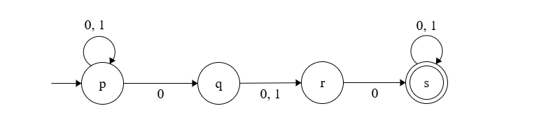
DFA
 | 0 | 1
- {p} | {p, q} | {p}
{p, q} | {p, q, r} | {p, r}
{p, q, r} | {p, q, r, s} | {p, r}
{p, r} | {p, q, s} | {p}
*{p, q, r, s} | {p, q, r, s} | {p, r, s}
*{p, q, s} | {p, q, s} | {p, r, s}
*{p, r, s} | {p, q, s} | {p, s}
*{p, s} | {p, q, s} | {p, s}

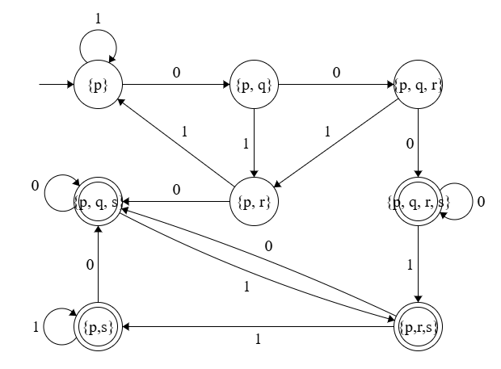
2.
DFA
Transitie Tabel
 | a | b | c
- *p | pq | q | s
*pq | pqr | qr | pq
q | qr | r | pq
s | s | s | s
*pqr | pqr | qr | pqr
*qr | qr | r | pqr
*r | q | r | pr
*pr | pq | qr | pr

Transitiediagram
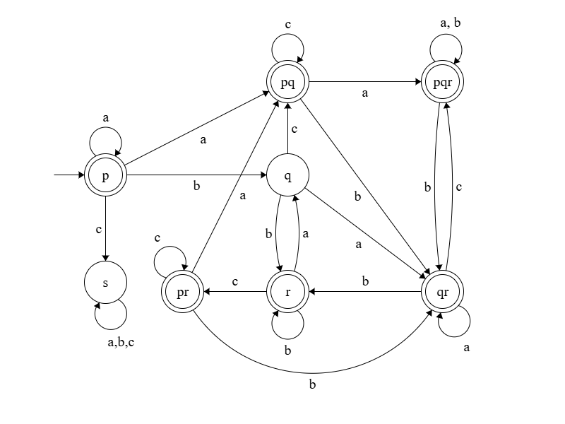

3.
transitietabel die bij deze NFA hoort
 | 0 | 1
- *q0 | ∅ | {q1, q}
q1 | {q} | ∅
*q | ∅ | ∅

DFA
D = {{q0, q1q, q, s}, {0, 1}, {q0, q1q, q, s} x {0,1} -> {q0, q1q, q, s}, {q0}, {q0, q1q, q}}
Transitietabel
 | 0 | 1
- *q0 | s | q1q
*q1q | q | s
*q | s | s
s | s | s

Transitiediagram
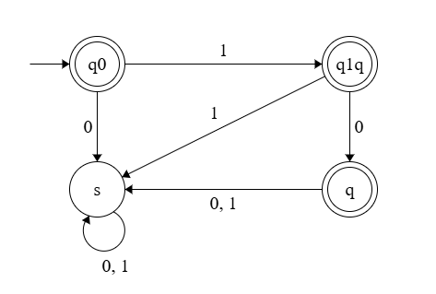
4.
Het diagram stelt een NFA, want niet alle symbolen worden gebruikt bij ieder toestand.
DFA
 | 0 | 1
- q0 | q1 | s
q1 | q2 | q1
*q2 | s | s
s | s | s
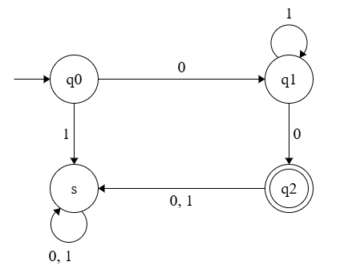
5.
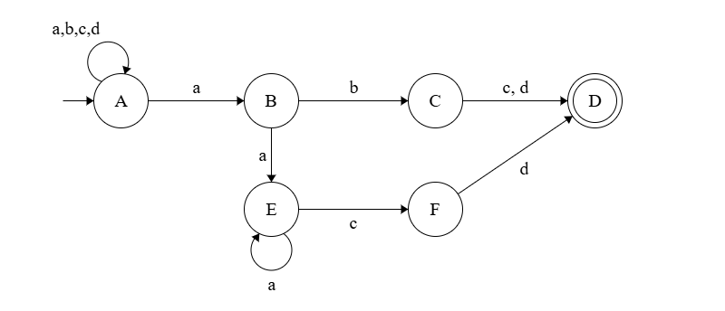
 | a | b | c | d
- A | {A, B} | {A} | {A} | {A}
B | {E} | {C} | ∅ | ∅
C | ∅ | ∅ | {D} | {D}
*D | ∅ | ∅ | ∅ | ∅
E | {E} | ∅ | {F} | ∅
F | ∅ | ∅ | ∅ | {D}

6.
DFA
 | a | b | c | d
- A | AB | A | A | A
AB | ABE | AC | A | A
AC | AB | A | AD | AD
*AD | AB | A | A | A
AF | AB | A | A | AD
ABE | ABE | AC | AF | A

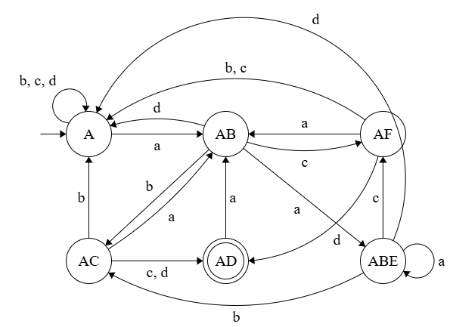

Reeks 4
1.
a.
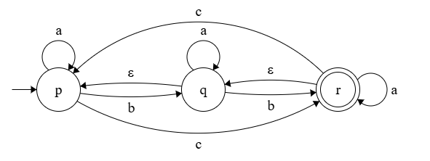

b.
Eclosure(p) = {p}
Eclosure(q) = {p, q}
Eclosure(r) = {p, q, r}
c.
 | ϵ* |  | a | ϵ* |  |  | ϵ* |  | b | ϵ*
p | {p} |  | {p} | {p} |  | p | {p} |  | {q} | {p, q}
q | {p, q} |  | {p, q} | {p, q} |  | q | {p, q} |  | {q, r} | {p, q, r}
r | {p, q, r} |  | {p, q, r} | {p, q, r} |  | r | {p, q, r} |  | {q, r} | {p, q, r}
 |  | ϵ* |  |  | c |  |  | ϵ*
p |  | {p} |  |  | {r} |  |  | {p, q, r}
q |  | {p, q} |  |  | {r} |  |  | {p, q, r}
r |  | {p, q, r} |  |  | {p, r} |  |  | {p, q, r}

NFA
 | a | b | c
- p | {p} | {p, q} | {p, q, r}
q | {p, q} | {p, q, r} | {p, q, r}
*r | {p, q, r} | {p, q, r} | {p, q, r}

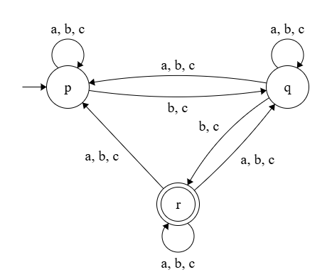

DFA
 | a | b | c
- p | p | q | r
q | q | r | r
*r | r | r | r

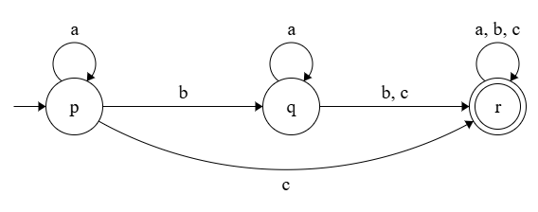

2.
e-NFA
 | ϵ | a | b | c
- p | {s, r} | {p, q} | ∅ | ∅
*q | {r} | ∅ | {p, q} | ∅
r | ∅ | {r, s} | ∅ | {q, r}
s | {r} | ∅ | ∅ | {s}

DFA
 | a | b | c
- {p, s, r} | {p, q, r} | ∅ | {r, s}
*{p, q, r} | {p, q, r, s} | {p, q, r} | {q, r}
∅ | ∅ | ∅ | ∅
*{p, q, r, s} | {p, q, r, s} | {p, q, r} | {q, r, s}
*{q, r} | {r, s} | {p, q, r} | {q, r}
*{q, r, s} | {r, s} | {p, q, r} | {q, r, s}
{r, s} | {r, s} | ∅ | {q, r, s}

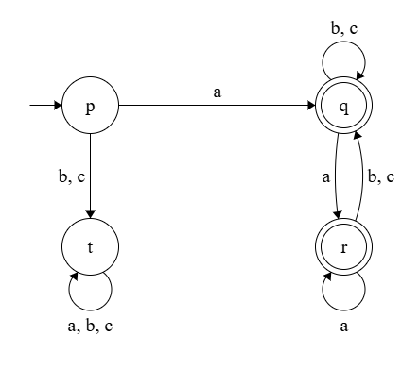
3.
Transitiediagram
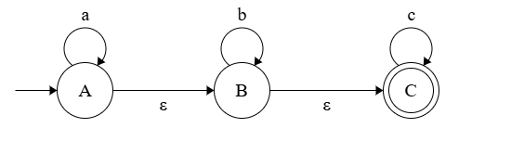
Transitietabel
 | ϵ | a | b | c
- A | {A, B, C} | {A} | ∅ | ∅
B | {B, C} | ∅ | {B} | ∅
*C | {C} | ∅ | ∅ | {C}

4.
DFA
Transitietabel
 | a | b | c
- *{A, B, C} | {A, B, C} | {B, C} | {C}
*{B, C} | ∅ | {B, C} | {C}
*{C} | ∅ | ∅ | {C}
∅ | ∅ | ∅ | ∅

Transitiediagram
